Glossary of Architectural Terms

ARCH A curved structural form designed to span an opening.

BARGEBOARD A board, ornately carved attached to the eaves of a gabled roof.
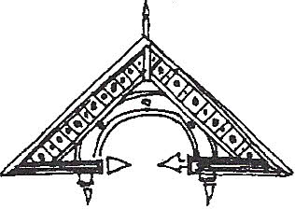
BRACKET A support element often found under eaves, shelves or other overhangs; often more decorative than functional.
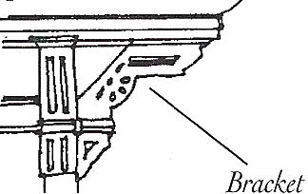

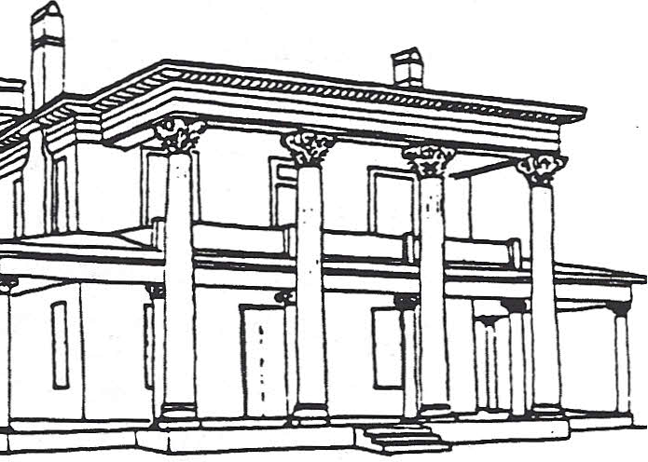
CAPITAL The uppermost part or head of a column or pilaster.

COLUMN A vertical support of round section. In classical architecture, the column consists of three parts: bass, shaft, and capital.

DENTIL (MOLDING) A band of small, square tooth-like blocks used as ornamentation.
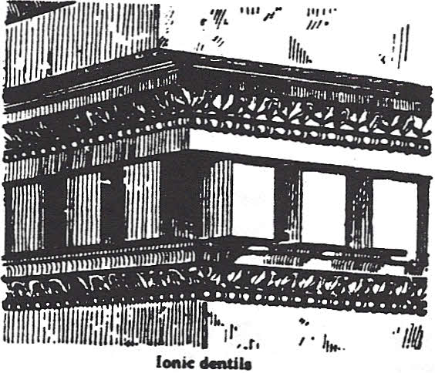

EAVES The projecting overhang at the lower edge of a roof.

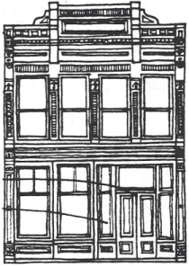 FACADE The front of a building; any other face of a building given special architectural treatment.

FANLIGHT A semicircular or fan-shaped
window over a door or window.

GABLE The triangle area formed by the slopes of a pitched roof at the end of a building. It extends from the eaves to the ridge of the roof.
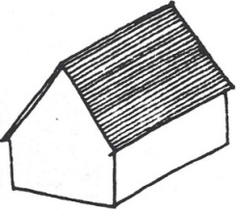

PALLADIAN WINDOW A three-part window
with a large arched central opening and flanking
rectangular side lights.

PEDIMENT A surface used ornamentally over doors or windows; usually rectangular but may be curved.
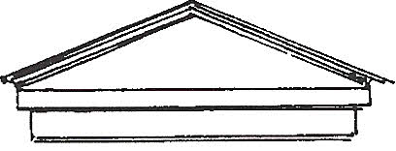

PILASTER A flat-faced representation of a column,
projecting from a wall.

TRANSOM A horizontal window over a door or entranceway.
VERANDA An open gallery or porch. Usually, a veranda has a roof, a railing, tall post and decorative elements.

